Chapter 11, Solution 81.

Design a problem to help other students to better understand how to correct power factor to values other than unity.

Although there are many ways to work this problem, this is an example based on the same kind of problem asked in the third edition.

Problem

A 120-V rms, 60-Hz electric hair dryer consumes 600 W at a lagging pf of 0.92. Calculate the rms-valued current drawn by the dryer.

How would you power factor correct this to a value of 0.95?

Solution

P = 600 W, 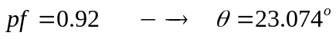
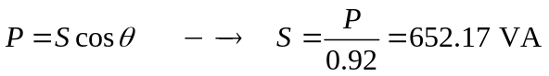
S = P+jQ = 600 + j652.17sin23.09º = 600 +j255.6
But 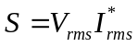.
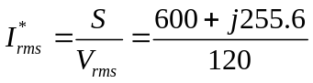

I_{rms} = 5 – j2.13 = 5.435∠–23.07˚A.

To correct this to a pf = 0.95, I would add a capacitor in parallel with the hair dryer (remember, series compensation will increase the power delivered to the load and probably burn out the hair dryer.

pf = 0.95 = 600/S or S = 631.6 VA and θ = 18.19˚ and VARs = 197.17

Thus,
VARs_{cap} = 255.6 – 197.17 = 58.43 = 120xI_{C} or I_{C} = 58.43/120 = 0.4869A

Next,
X_{C} = 120/0.4869 = 246.46 = 1/(377xC) or C = 10.762 µF

